**CREATE SOCIAL MEDIA POST**

**INTRODUCTION**

* 1. **OVERVIEW:**

Social media refers to the means of interaction among people in which they create, share and / or exchange information and ideas in virtual community and networks. The office of communications and marketing manages the main facebook , twitter, instagram,linkedin and youtube accounts.

* 1. **PURPOSE :**

The main purpose of social media posts is to

increase brand awareness and visibility. The

more people know about your social media

presence , the more people you can

potentially turn into customers. Social media

post also help in building relationship with

your audience when they engage with your

posts.

2**.PROBLEM DEFINITION & DESIGN THINKING:**

**2.1 EMPATHY MAP:**

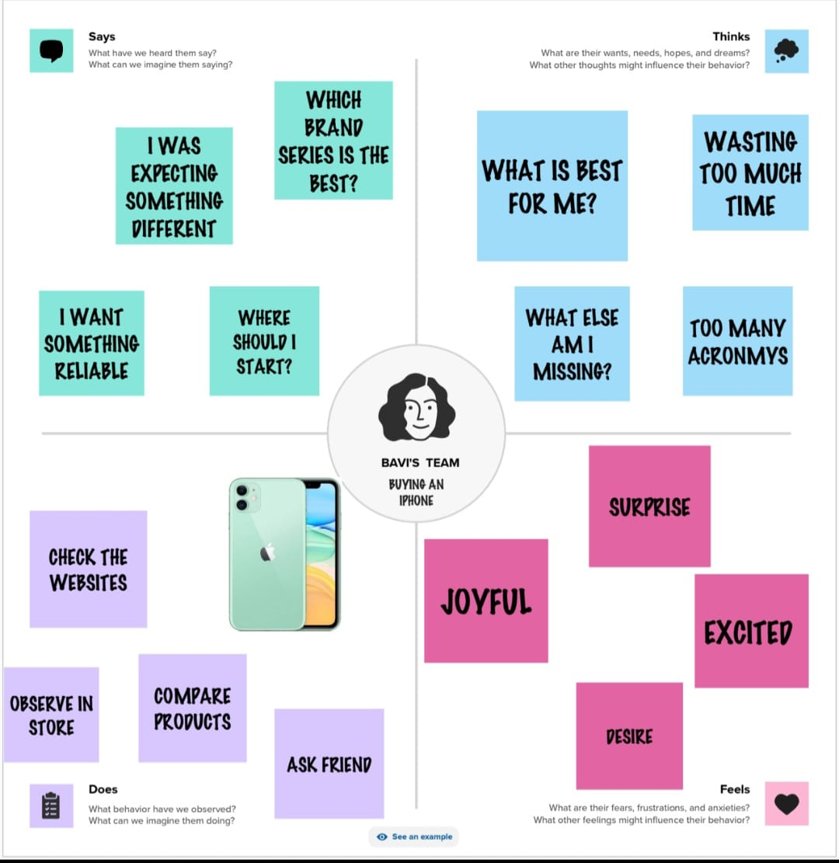

**2.2 IDEATION & BRAINSTROMING MAP:**

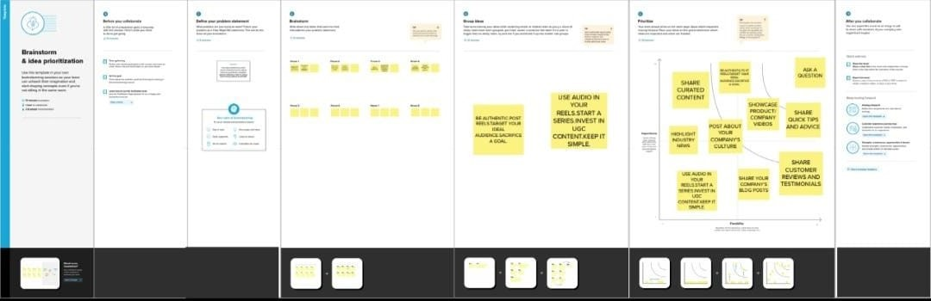

**3.RESULT :**

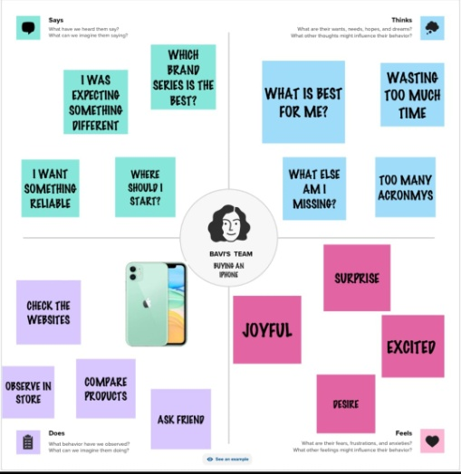



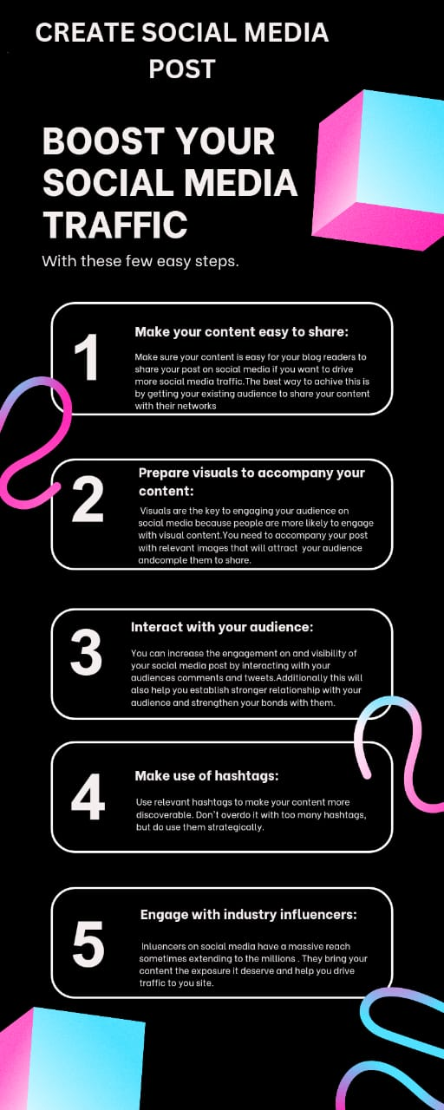

**4.ADVANTAGES OF SOCIAL MEDIA :**

* You reach large audiences.
* You have a direct connection with your audience.
* You can create organic content.
* You have access to paid advertising services.
* You build your brand.
* You drive traffic to your website.
* You can evaluate your performance.

**DISADVANTAGES OF SOCIAL MEDIA:**

* Cyberbullying.
* Hacking on social media.
* Reduces face to face communication skills.
* Fake news.
* People’s addiction to social media.
* Social media is harmful to one’s health.
* Spending time on social media is a waste of time.
* Social media causes sleep issues.

**5.APPLICATIONS :**

It allows us to easily connect with family,friends and colleagues around the world and share our thoughts , ideas and experiences in an instant. It also provides us with a platform to receive and share news , updates and opinion from experts and influential people. social media is an important part of today’s world. It helps people stay connected and share ideas, thoughts and opinions with others in a safe and secure environment . It can also be used to promote businesses , organizations , and causes , as well as to stay informed about current events and trends.

**6.CONCLUSION :**

In conclusion social media has plenty of good uses as it allows or events that began locally to gain or global or world wise attention . This allows to become an amazing platform to make the world connect and spread information faster then ever in the history of mankind. Social media is a really convenient and important communicate network for all the people nowadays .We can use it to know friends and keep contact with friends that came from different countries. People could also sell things on social media freely with could reduce the expenditure of advertisements .

**7.FUTURE SCOPE OF SOCIAL MEDIA :**

Social media will be more integrated into personal , social,and business lives . without realizing it ,these platforms will be a natural part of our lives , streamlining our everyday activities and work . social media will have longer –term implications for individuals as a result of a lived in public.